**Date:17/10/2020**

**Practical no 7**

**AIM:** Write and test a program to get the number of items in a DropDownlist / combo box.

**Theory**

**WebElement** : Represents an HTML element. Generally, all interesting operations to do with interacting with a page will be performed through this interface. WebElements objects are Selenium(Java) equivalent of HTML elements in the UI such as Form, Button, Select, A, P, H0-6, etc..

**org.openqa.selenium.support.ui.Select** : Models a SELECT tag, providing helper methods to select and deselect options.

**java.util.List** : This data structure allows one two list down WebElements in Java which could be sub- elements or nested elements under the selector. The object has methods such as **object.size()** which returns the size of the list, **Selectobject.getOptions()** which returns a select option element from the object.

**Select.selectByVisibleText()** : Select all options that display text matching the argument. That is, when given ”Bar” this would select an option like: Bar .

**Select.selectByIndex():** Select the option at the given index. This is done by examining the ”index” attribute of an element, and not merely by counting.

**Code:**

**Part A**

|  |
| --- |
| **package** prac77;  **import** org.openqa.selenium.By;  **import** org.openqa.selenium.WebDriver;  **import** org.openqa.selenium.chrome.ChromeDriver;  **import** org.openqa.selenium.support.ui.Select;  **import** java.util.List;  **import** org.openqa.selenium.WebElement;  **public** **class** Prac7 {  **static** String *driverPath*="E:\\tycs\\stqa prac\\prac2\\chromedriver_win32\\chromedriver.exe";  **public** **static** **void** main(String[] args) {  System.*setProperty*("webdriver.chrome.driver", *driverPath*);  WebDriver driver= **new** ChromeDriver();  driver.get("E:/tycs/stqa%20prac/prac7/index.html");  Select selectDropdown = **new** Select(driver.findElement(By.*id*("bikes")));  List<WebElement> listOptionDropdown = selectDropdown.getOptions();  **int** dropdownCount = listOptionDropdown.size();  System.***out***.println("Total Number of item count in dropdown list = " + dropdownCount);  driver.close();  System.***out***.println("performed by krunal 713");  }  } |

**Output:-**

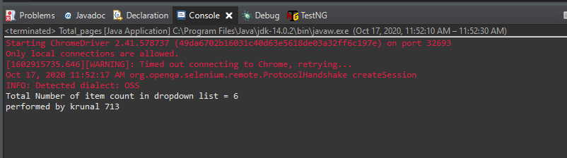

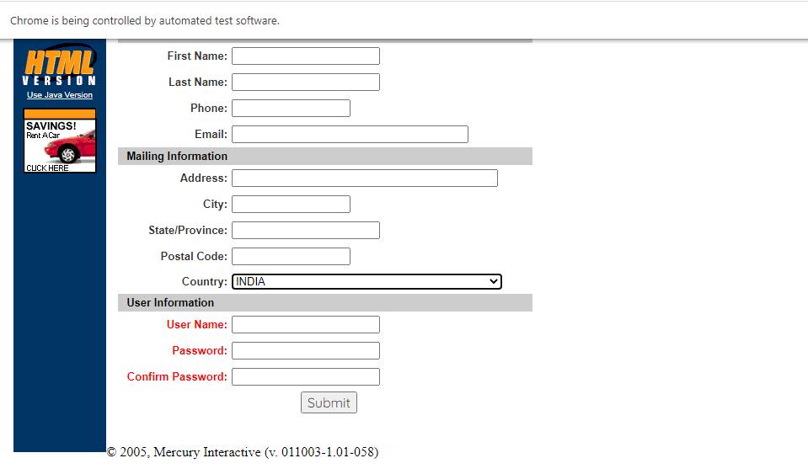

**Part-B**

|  |
| --- |
| **package** stqapracccc;  **import** org.openqa.selenium.By;  **import** org.openqa.selenium.WebDriver;  **import** org.openqa.selenium.chrome.ChromeDriver;  **import** org.openqa.selenium.support.ui.Select;  **public** **class** Total_pages {  **static** String *driverPath*="E:\\tycs\\stqa prac\\prac2\\chromedriver_win32\\chromedriver.exe";  **public** **static** **void** main(String[] args) **throws** InterruptedException {  //----PART2A ---------//  System.*setProperty*("webdriver.chrome.driver", *driverPath*);    String baseUrl = "http://demo.guru99.com/test/newtours/register.php";  WebDriver driver= **new** ChromeDriver();  driver.get(baseUrl);  Select drpCountry = **new** Select(driver.findElement(By.*name*("country")));  drpCountry.selectByVisibleText("INDIA");  Thread.*sleep*(8000);    //----PART2B ---------//  driver.get("http://jsbin.com/osebed/2");  Select fruits = **new** Select(driver.findElement(By.*id*("fruits")));  fruits.selectByVisibleText("Banana");  fruits.deselectByIndex(1);  Thread.*sleep*(8000);  driver.close();  System.***out***.println("performed by krunal 713");  }  } |

**Output**

